**PSA monochrome LCD display MENU access** 3May2018

MENU access on the display allows operations such as setting data time and language.

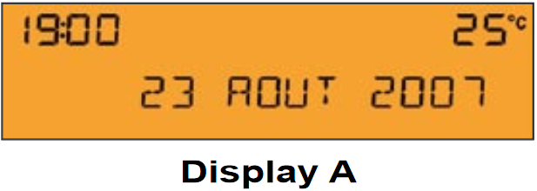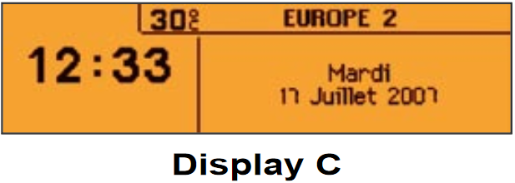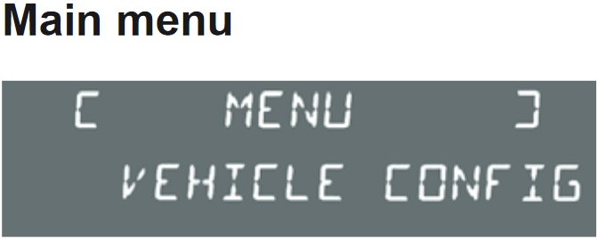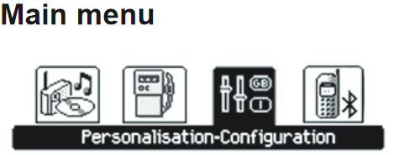

Vehicles fitted with CP2 can access menu via stalk control in the absence of the factory radio.

No Function

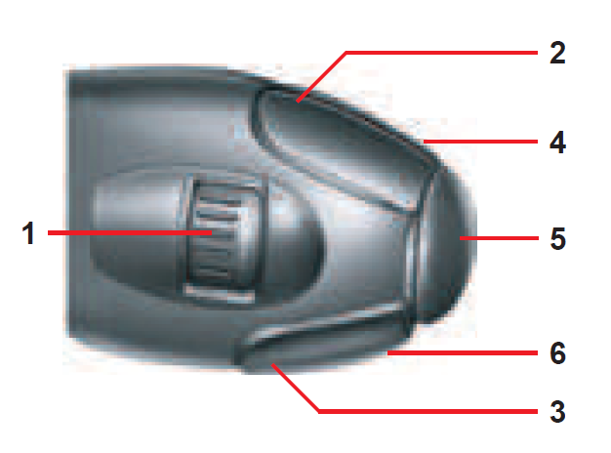

ROTARY:

↑ - RIGHT

↓ - LEFT

OK

UP

DOWN

ESC

----------------------------------------------------------------------------------

**Definitions:**

*Long press – press and hold button(s) for 2 seconds or more.*

*Press – press and release button.*

**To access MAIN MENU use the following steps as a guide:**

*Long press* **VOLUME UP and VOLUME DOWN** at the same time **(MUTE)** to switch to Main Menu mode. From here on Main menu and sub menus can be selected. You will during this time lose control of the radio via the steering wheel controls.

Press **VOLUME UP and VOLUME DOWN presses** to scroll through available entries within the menu.

Use **ROTARY** to scroll through available menu entries **OR** to change values/units such as time and date, language etc.

*Press* **OK** to go into the sub-menu that you have just selected. This item can be seen highlighted on your LCD display.

*Press* **ESC** to go back a level in the menu

When completed and to return to allow the steering wheel controls to control the radio again, either IGN cycle or *Long press* **VOLUME UP and VOLUME DOWN** at the same time **(MUTE)** to switch to Main Menu mode

------ END -----